Let’s take a quick tour of your Google Classroom -

- Once you have completed the set up instructions and “Joined” all of the classes your teachers invited you to join, your “Dashboard” should look similar to this: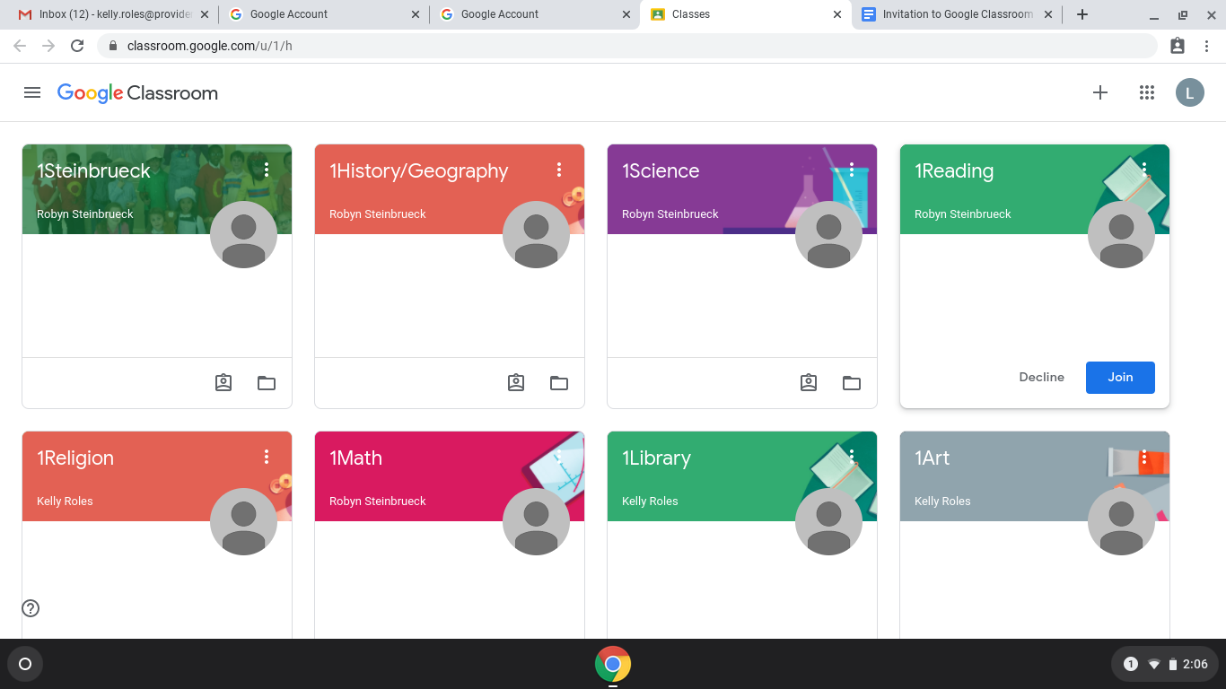

Remember that you can click/touch and drag “folders” around your screen to put them in the order that works best for you.

- Visit your “Homeroom”

Your first step each day will be a visit to your “homeroom” folder. It typically has your grade level and your teachers last name. If you look at the image above, you will see “1Steinbrueck” in the top left corner. This is Mrs. Steinbrueck’s “homeroom” folder.
Can you find your “homeroom” folder? Click on your “homeroom” folder to visit the classroom.

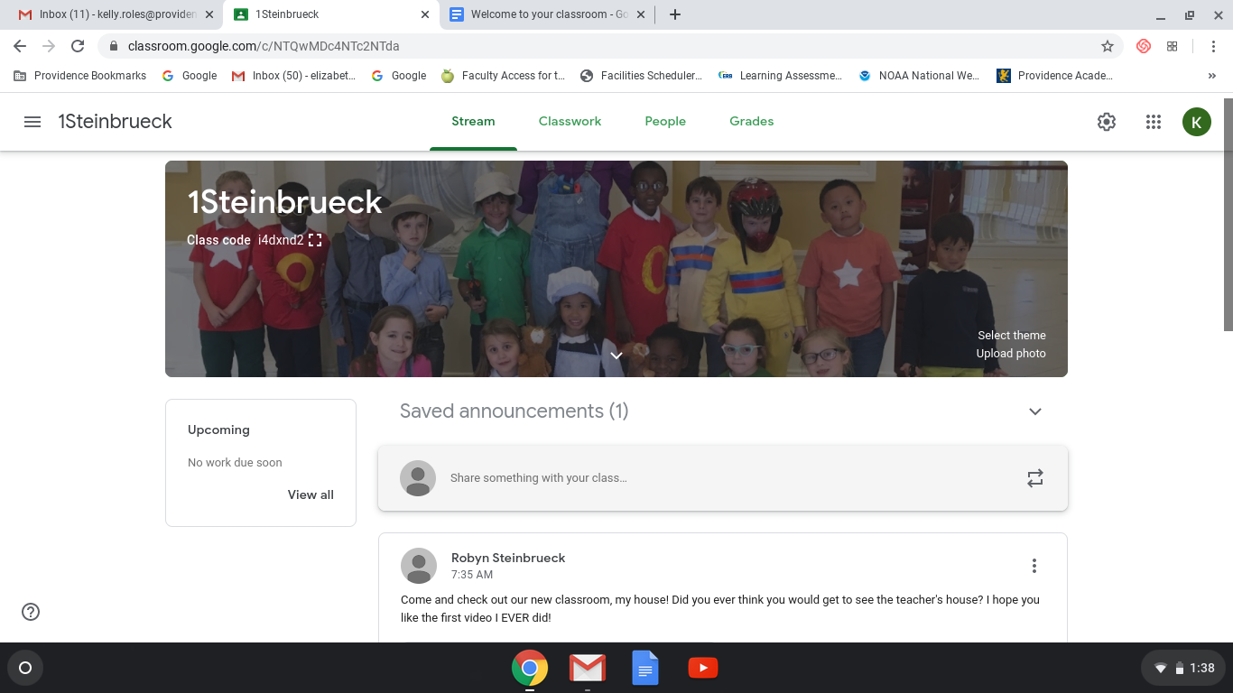

Every morning, in your “homeroom’ folder, you will find a links to Daily Mass (optional), Announcements/Birthdays with Dr. Flanders, Attendance, Noon Prayer with Mr. Wagner,
Stories with Mrs. Commers, Class Schedule and your morning greeting from your teacher.

You will see all of this on the first page that opens up, otherwise known as the “Stream”.
Think of it like a stream. It is a running list of everything your teacher posts in “homeroom” & the best place to start your day.
Your morning announcement will look something like this:
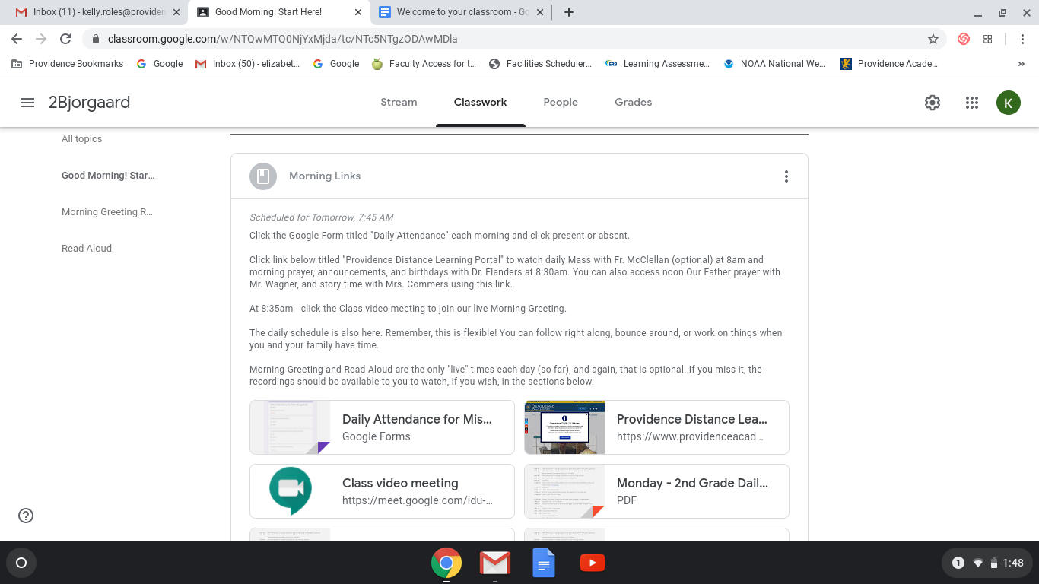

In the “Morning Announcement” you will find a schedule. The schedule is flexible.
Keep in mind that all “live” meetings are recorded and can be viewed at any time.

The schedule may invite you to visit different classrooms throughout your day or direct you to different “Topics” on the “Classwork’ page.

- Working in your Subject Folders

Try closing out of your “homeroom” folder. The easiest way to do this is to click on the 3 lines in the left corner, next to your “homeroom” name (In the photo above they are next to 2Bjorgaard). Then click on “Classes”. This will take you back to your main “Dashboard” page.

Once there, open your “Math” folder. (PreK & K will find most of their subjects and work under the “Classwork” tab in the homeroom folder. Only Specialists - Music, PE, Spanish, Library, Art - will have their own folders.) After clicking on the “Math” folder, look at the top of the page and click on “Classwork”. It will look something like this:
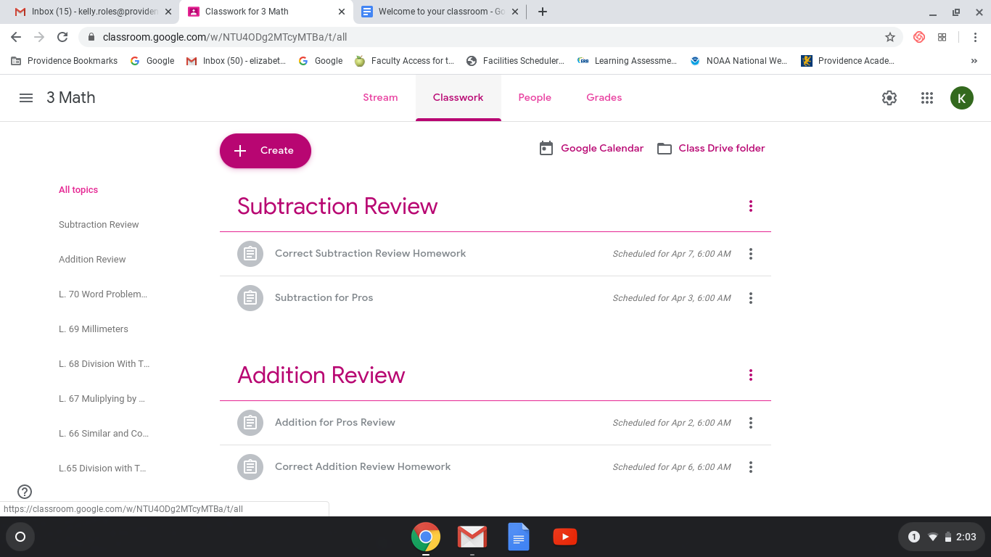

“Classwork” is where you will find all of your assignments and complete most of your work. Follow your teachers’ instructions regarding which subjects and assignments to complete each day/week.

- Contacting your teacher

When you have a question or want to contact your teacher, you can do that through email. Click on the “People” tab at the top of the page. Do you see your teachers name? Click on the “Stoplight” (3 dots) next to your teacher’s name and then click email.
Your email account will open with the teachers’ address. Give it a try! Email your teacher “Hello” and let them know you are learning how to use “classroom”.

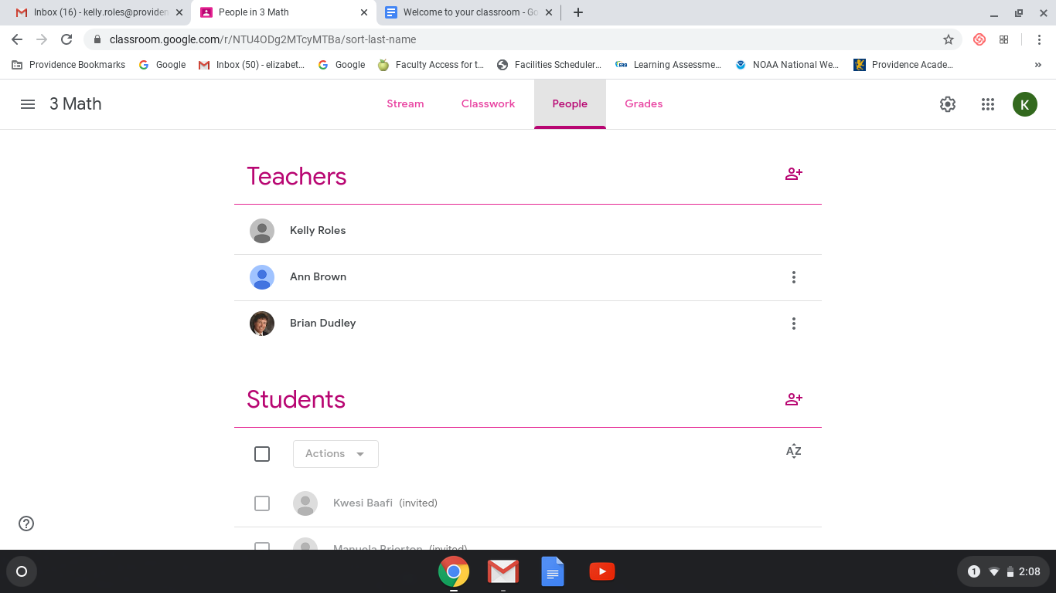

Hopefully you enjoyed this quick little tour and are feeling more confident about learning in this new online environment. Don’t hesitate to reach out to your teacher or Mrs. Roles
(kelly.roles@providenceacademy.org) if you have questions or concerns. Remember, It’s like starting at a new school. Together we will find our way. The good news is you’ll see a lot of friendly faces that you already know. Good luck! & Have Fun.

